Setting up Application Environment Docker CLI Installation

**Step 1.** Download Docker from docker.com and install it by running the Docker Desktop Installer.exe file

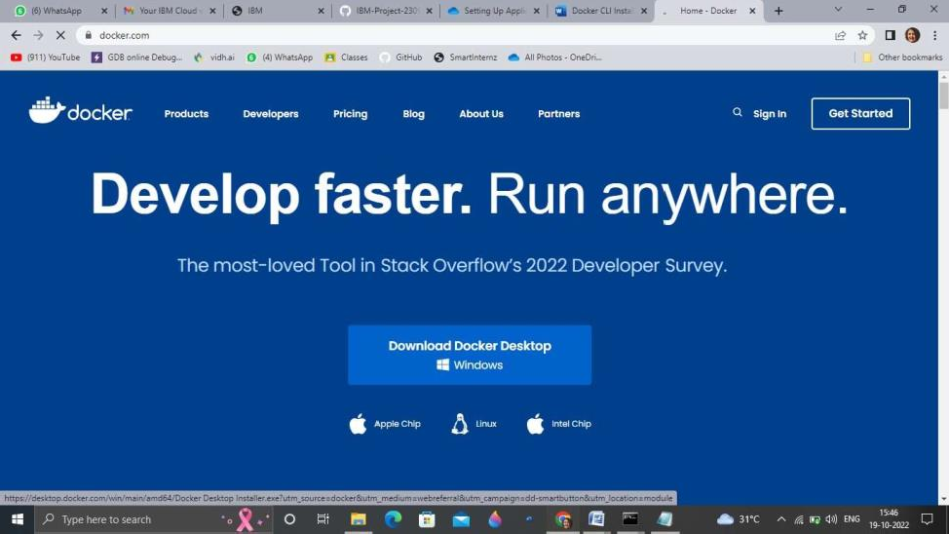

**Step 2.** Goto hub.docker.com register and create an account and login with the same

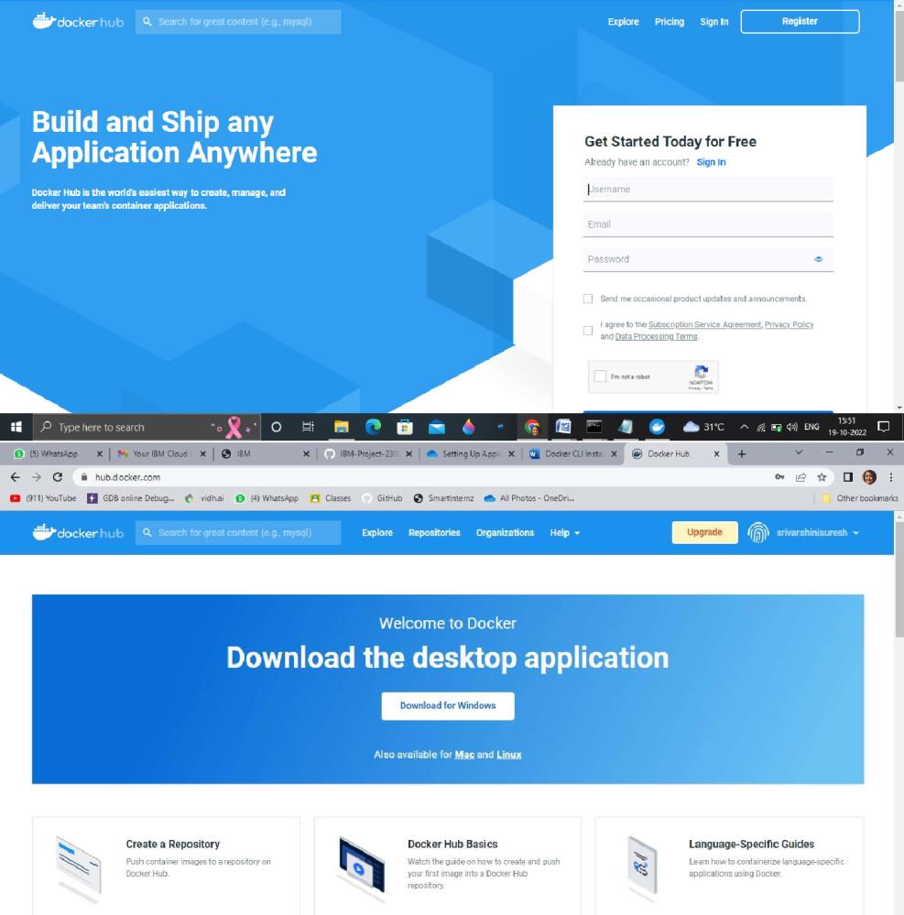

**Step 3.** Open Docker Desktop and start creating containers and images

